# Alarm Matrix

## Introduction

The alarm matrix defines which alarms will show on which workstation or panel, what a workstation or panel is allowed to do and which rights workstations or panels have. This all in sequential order and within range of class rules.

If you start up the system the first time, the matrix will be set to standard. If this is not the case you can remove the “AlarmPanels.uc.ini” out of the network folder and restart. The FT NavVision© program will start a new default matrix.

*:although an engineer or administrator can alter these settings, we at FT NavVision© will deliver the system within class rules. Any alteration is solely the responsibility of the administrator.*

## The matrix

The matrix can be found in FT NavVision© under Tools/Alarm Stations (see Figure 9‑1).

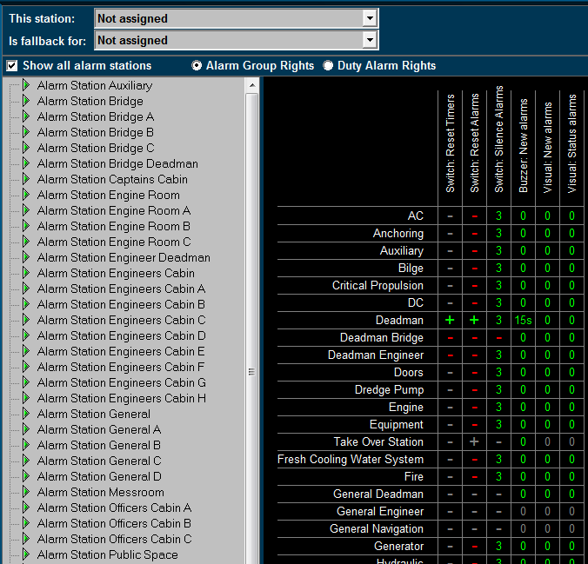

Figure 9‑1: Station Matrix

As you can see the default settings are already in place. Things you cannot do are protected and will show a grey line. Additional settings that are allowed are shown with a red line.

#### This station

Defines the station this computer is set on. All the alarm settings of that station are also valid for the PC screen you are working on. If set to “Not Assigned” no specific alarm restriction is set. All alarms will be visible and can be silenced or acknowledged.

#### Is fallback for

This defines which rights this computer will get once the station set in this box is not working. If this would be the wheelhouse pc it could be a fallback station for the engine room. When the engine room pc should be out for whatever reason, the wheelhouse station will take over the tasks and rights of the engine room pc. This way all the important tasks can still be handled.

#### Show all alarm stations

Ticking this box switches between showing all, or all available Alarmstations.

#### Alarm group rights/Duty alarm rights

Choose either of these two to switch between changing alarm group rights or duty alarm rights.

#### Adjustments

On the left pane you can choose the alarm station to be adjusted. The adjustments will only be valid for that particular station. When you choose to set this station (i.e. Alarm station bridge) on an alarm panel or another Server or client, these will have the same settings automatically.

*:*

*All the settings in the diverse alarm stations will automatically be synchronized to all the other pc’s (servers and clients) which are connected. You won’t have to change all PC’s separately. On the left panel you will find all the groups that are available in the system.   
Groups that are in use by the system are shown in the right pane. Other groups will not be available. You can set the alarm options for each separate group.*

*When finished, all alarm options of each alarm group will be set within the specific alarm stations.*

The following options are available for Alarm Group Rights:

|  |  |
| --- | --- |
| **Alarm group option** | **Explanation** |
| Visual: status alarms | Shows any alarm even if it is acknowledged |
| Visual: new alarms | Shows new alarms for this group |
| Buzzer: new alarms | Sounds buzzer on new alarms for this group |
| Switch: silence alarms | Allows to silence the alarms for this group |
| Switch: reset alarms | Allows to acknowledge the alarms for this group |
| Switch: reset timers | Allows resetting of timers (i.e. dead man’s timer) |

Table 9‑1: Alarm Group Rights

#### How to set Alarm Group Rights

Fields are set separately by pointing the mouse onto that field and right click it. The “Reset” fields will turn to “+” and the other fields will turn to “0” which simultaneously means that the delay is set to “0” minutes.

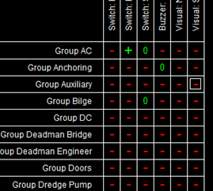

If you want to set a field to a higher delay (i.e. you want to silence an alarm for 3 minutes) you must left click the field. A menu will appear where you can change the settings including the delay time. Check “Enable the selected cells” and choose a delay time. You can choose the delay time in minutes or seconds by checking the appropriate box (seeFigure 9‑2).

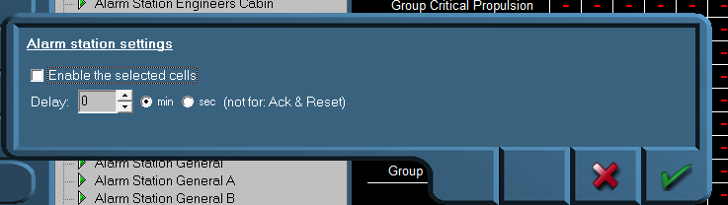

Figure 9‑2: Alarm station settings

In addition, you can do this for different cells at the same time, by clicking and dragging the mouse over the preferred cells (see Figure 9‑3).

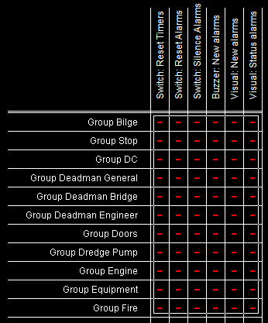

Figure 9‑3: Select by dragging

If you want to disable the alarm settings, deselect the checkbox “Enable the selected cells”.

The following options are available for Duty Alarm Rights:

|  |  |
| --- | --- |
| **Alarm group option** | **Explanation** |
| Call Allowed | Marks if other stations are allowed to call this station |
| Bridge Duty | Marks if station can be selected for Bridge Duty |
| Bridge Duty Select | Marks if station can select bridge duty |
| ER Duty | Marks if station can be selected for ER Duty |
| ER Duty Select | Marks if station can select ER duty |
| Activate station | Marks if station is allowed to switch on or off |

Table 9‑2: Duty Alarm Rights

The “Call Allowed” and “Duty” is shown in the alarm mimic on the main workstations (see Figure 9‑4 and Figure 9‑5).

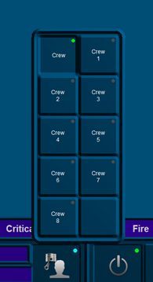

Figure 9‑4: Duty Select function

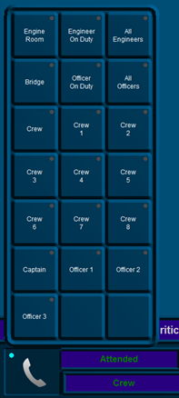

Figure 9‑5: Call Select function

*: The FT NavVision© fields for call and duty select can be found under Field Settings/Alarm/Crew/Crew Alarms.*

## Background

To elaborate a little bit further we will explain a bit more about the use of alarm stations. Each station will be in a particular part of the ship (i.e. wheelhouse, engine room, crewmess, chief engineer cabin etc.) All these stations have their own rights on which alarms they can hear or see and how they can act upon such an alarm. For example, the engine room is the place where all the alarms normally will be visible and almost always the only place where alarms can be acknowledged. This is because regulations require that alarms can only be acknowledged on that part of the ship where you can act upon the alarm and take precautionary action on that alarm. Now in the crewmess (a public space) all kind of people have access to the workstation. It is not advisable that these people have rights to acknowledge the alarm. So in this space you can set the Alarmstation rights for the crewmess, so that they don’t have the rights to acknowledge.

You can imagine that in the wheelhouse they do not want to see all the alarms concerning propulsion etc. merely navigational alarms are mostly enough on the bridge. Here you can set the alarm stations to only show navigational alarms and not propulsion alarms.